**Microprocessor Lab**

Laboratory Activity No. 1

**Familiarization with TinkerCAD**

|  |
| --- |
|  |

Score

*Submitted by:*

**Oliva, Vanessa A.**

**<Saturday 4 pm – 7 pm > / <CpE 0412-2 >**

*Date Submitted*

**16-09-2023**

*Submitted to:*

**Engr. Maria Rizette H. Sayo**

1. Exercise

a. A process in Tinkercad where we can develop electronic circuits that can be quickly updated, modified and tested is called ___Prototyping_______.

b. In Tinkercad, _______Start Simulation and Stop Simulation______ tests the working of the circuits and the components.

c. The device used to assemble and connect the various components is known as __Breadboard______

d. In an electronic circuit with LED, the positive end of the circuit should be connected to

____Anode_______ and negative end should be connected to ____Cathode_______ of the LED.

e. A _____Resistor_______ is used to restrict the flow of current to electrical components

2. Label the following:

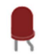

1. Anode and Cathode in a LED

Anode (+)

Cathode (-)

1. Different parts of breadboard

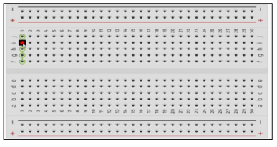

Edge

Main Area

Edge

1. List the electronic components used in a circuit assembly.

* Resistors
* Capacitors
* Diode
* Battery
* LED Light
* Switch
* Transistor
* Pushbutton
* Potentiometer
* Sensor
* Inductors
* Integrated Circuits
* Logic Gates
* Mutimeter/Meters
* Osciloscope
* Power Supply
* Function Generator
* Microcontrollers
* Electrical Wires
* Fuse
* Relay

Conclusion:

Learning and experimenting with TinkerCad allows us to gain a better understanding of the realms of electronic circuits. We can design and simulate our own electronic circuits on this platform and learn how they work without spending a lot of money on electric components, making it ideal for us students and other beginners in this field. Aside from that, gaining hands-on experience in TinkerCad familiarizes us with what to do when applying our knowledge of electronic circuits in reality which is a better way of effective way of learning for us students.